Rolling correlation: USDJPY and USDCAD
Method 05 / daily log returns / windows 20, 60, 100 / Low-value

Study setup
Logical pair: USDJPY , USDCAD
Broker symbols: USDJPY_i , USDCAD_i
Tier: Low-value (low_value)
Snapshot: 2026-11-03_majors_alpari_D1
Timeframe: D1
Matched return window: 1999-01-05 to 2026-11-02 (UTC bar dates)
Matched return count (rows before rolling): 7186
Dropped unfinished last bar dated 2026-11-03 UTC after a tick-volume check against the prior complete day.
Rolling windows W: 20, 60, 100 trading days
Live-shaped n for each score: n = W (not the full history length)
Complete matched rows (CSV): USDJPY-USDCAD_Rolling_D1.csv
Complete matched rows (HTML): USDJPY-USDCAD_Rolling_D1_data.html

Method carried forward
Rolling Pearson r is computed on matched daily log returns of close, ln(close_t / close_t-1), in the broker quote direction. Quotes are not inverted. For each day t with a full window, r_W uses the last W matched return pairs ending at t. That live-shaped sample size is W (20, 60, or 100), not the full multi-year history. The first W-1 days have no score. r is symmetric under swap of the two symbols. A high |r| in one window does not prove cause, lead-lag, or a trading signal. Short windows are noisier; long windows are slower to reflect a break.
How to read a live day: after both daily candles close, the newest r_20 uses the last 20 matched log returns, r_60 the last 60, and r_100 the last 100. Compare those three to each other and to the full-sample baseline below. A break is when the short window moves far from the baseline or flips sign while the baseline was meaningful.

Full-sample Pearson baseline (method 01 v001)
Copied full-sample Pearson r for USDJPY-USDCAD: 0.027603. This is a historical average link, not the live state.

Rolling results
W | latest_r | mean | median | min | max | std | pct_|r|>=0.4 | pct_|r|>=0.7 | n_roll
20 | 0.487295 | 0.124359 | 0.144234 | -0.864633 | 0.866072 | 0.339732 | 31.46 | 3.22 | 7167
60 | 0.516258 | 0.115353 | 0.135516 | -0.747187 | 0.705343 | 0.27449 | 19.59 | 0.45 | 7127
100 | 0.418713 | 0.110717 | 0.12587 | -0.665135 | 0.65141 | 0.257416 | 17.79 | 0 | 7087
n_roll is the number of days that had a complete window. pct_|r|>=0.4 and pct_|r|>=0.7 are the share of those days where the absolute rolling correlation cleared the threshold.

Conclusion
For USDJPY and USDCAD, full-sample Pearson baseline r=0.0276. Latest rolling scores: r_20=0.4873, r_60=0.5163, r_100=0.4187. Stability: moderate window-to-window variation. Agreement with baseline: r_20=0.487 far from baseline (0.46); r_60=0.516 far from baseline (0.49); r_100=0.419 far from baseline (0.39). Tier line: low interest historically; check only if a short window spikes. This is a monitoring summary, not a trade signal.

What to look at in this file next time
1) Latest r_20 vs r_60 vs r_100 in the results table. 2) Whether short-window latest has the same sign as the baseline. 3) The rolling chart for stretches where |r| collapsed. 4) The CSV if you need a different chart later.

Charts
Rolling Pearson r (20 / 60 / 100)
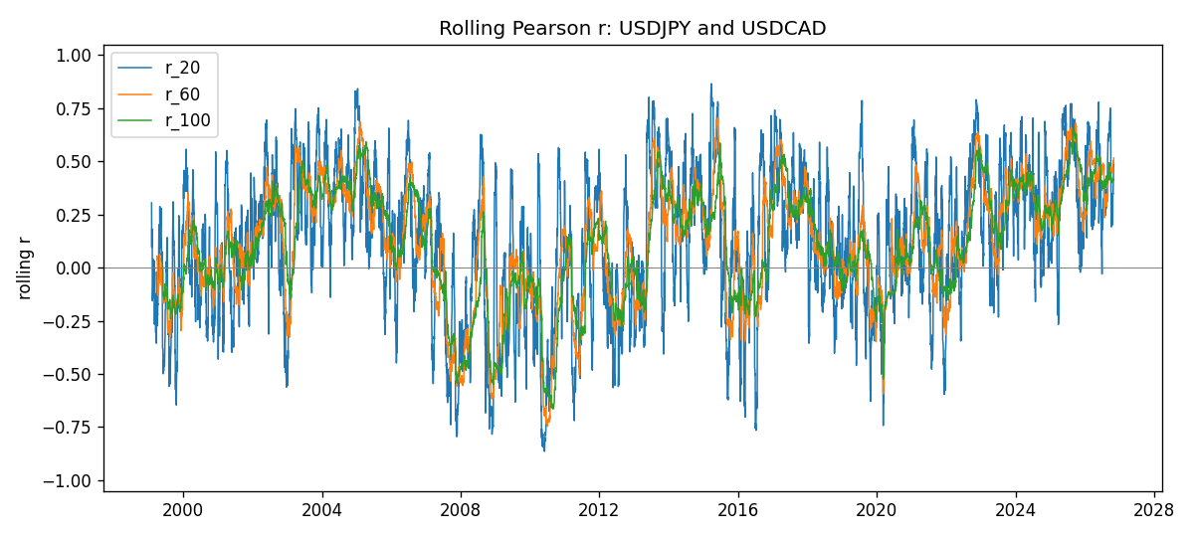
Daily closes

Daily log returns
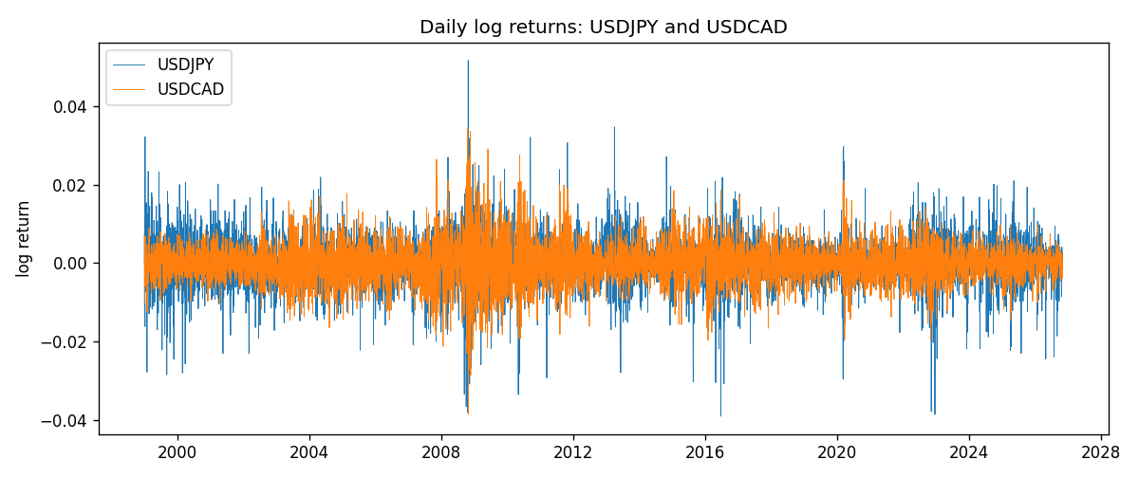

Data report
Every matched row with r_20, r_60, and r_100 is in the sibling CSV and HTML. This Word section holds column summaries and the first and last 15 rows of the rolling table.
Columns: time, USDJPY_close, USDCAD_close, USDJPY_tick_volume, USDCAD_tick_volume, USDJPY_log_return, USDCAD_log_return, r_20, r_60, r_100
Column summaries
column | count | mean | std | min | 25% | 50% | 75% | max
USDJPY_close | 7186 | 113.821 | 19.2378 | 75.811 | 104.383 | 111.018 | 120.694 | 163.851
USDCAD_close | 7186 | 1.2668 | 0.168895 | 0.916 | 1.11817 | 1.29848 | 1.3724 | 1.6137
USDJPY_tick_volume | 7186 | 106330 | 179430 | 149 | 9948.5 | 53187 | 92874.5 | 1.80351e+06
USDCAD_tick_volume | 7186 | 81037.8 | 147318 | 37 | 5546.5 | 40944 | 71631 | 1.41082e+06
USDJPY_log_return | 7186 | 5.053e-05 | 0.00620694 | -0.039082 | -0.00319936 | 0.00011986 | 0.0034094 | 0.0518402
USDCAD_log_return | 7186 | -1.555e-05 | 0.00514357 | -0.0385975 | -0.00283709 | 4.741e-05 | 0.00272359 | 0.0343632
r_20 | 7167 | 0.124359 | 0.339732 | -0.864633 | -0.103608 | 0.144234 | 0.384855 | 0.866072
r_60 | 7127 | 0.115353 | 0.27449 | -0.747187 | -0.0824498 | 0.135516 | 0.320143 | 0.705343
r_100 | 7087 | 0.110717 | 0.257416 | -0.665135 | -0.0659539 | 0.12587 | 0.315086 | 0.65141
First 15 matched rows
time | USDJPY_close | USDCAD_close | USDJPY_log_return | USDCAD_log_return | r_20 | r_60 | r_100
1999-01-05 | 111.92 | 1.5123 | -0.000178683 | -0.0101317
1999-01-06 | 112.77 | 1.5118 | 0.00756602 | -0.000330677
1999-01-07 | 111.33 | 1.5141 | -0.0128516 | 0.00152021
1999-01-08 | 110.8 | 1.511 | -0.00477199 | -0.00204952
1999-01-11 | 109.02 | 1.5057 | -0.0161954 | -0.00351378
1999-01-12 | 112.6 | 1.5157 | 0.0323104 | 0.00661947
1999-01-13 | 113.52 | 1.5226 | 0.00813732 | 0.00454202
1999-01-14 | 113.52 | 1.5332 | 0 | 0.00693765
1999-01-15 | 114.15 | 1.5245 | 0.00553434 | -0.00569057
1999-01-18 | 114.16 | 1.526 | 8.76002e-05 | 0.000983445
1999-01-19 | 113.52 | 1.5302 | -0.00562194 | 0.00274851
1999-01-20 | 112.91 | 1.5211 | -0.00538799 | -0.00596469
1999-01-21 | 113.87 | 1.5146 | 0.00846641 | -0.00428238
1999-01-22 | 114.56 | 1.5184 | 0.00604126 | 0.00250577
1999-01-25 | 113.72 | 1.5197 | -0.00735942 | 0.000855798
Last 15 matched rows
time | USDJPY_close | USDCAD_close | USDJPY_log_return | USDCAD_log_return | r_20 | r_60 | r_100
2026-10-13 | 158.305 | 1.4214 | -0.00189328 | -0.00463957 | 0.34867 | 0.4589 | 0.413795
2026-10-14 | 158.317 | 1.42356 | 7.58002e-05 | 0.00151848 | 0.236356 | 0.460582 | 0.412514
2026-10-15 | 158.024 | 1.41843 | -0.00185243 | -0.00361015 | 0.273653 | 0.462113 | 0.413408
2026-10-16 | 157.964 | 1.41357 | -0.000379761 | -0.00343221 | 0.338387 | 0.454781 | 0.410111
2026-10-19 | 158.517 | 1.41091 | 0.00349468 | -0.00188353 | 0.235671 | 0.445549 | 0.39891
2026-10-20 | 158.16 | 1.40569 | -0.00225466 | -0.0037066 | 0.285504 | 0.447616 | 0.401385
2026-10-21 | 158.108 | 1.4045 | -0.000328835 | -0.000846918 | 0.201619 | 0.447386 | 0.402649
2026-10-22 | 156.755 | 1.40081 | -0.00859427 | -0.00263073 | 0.231176 | 0.458912 | 0.412753
2026-10-23 | 156.81 | 1.40085 | 0.000350804 | 2.85545e-05 | 0.349333 | 0.484055 | 0.411596
2026-10-26 | 157.458 | 1.40093 | 0.00412387 | 5.71066e-05 | 0.346147 | 0.495114 | 0.410422
2026-10-27 | 157.894 | 1.40449 | 0.00276517 | 0.00253795 | 0.397471 | 0.496483 | 0.413949
2026-10-28 | 157.743 | 1.39911 | -0.000956795 | -0.00383793 | 0.407707 | 0.500269 | 0.412501
2026-10-29 | 157.683 | 1.39895 | -0.000380438 | -0.000114365 | 0.419724 | 0.503003 | 0.419022
2026-10-30 | 157.516 | 1.39751 | -0.00105965 | -0.00102987 | 0.473604 | 0.49405 | 0.418227
2026-11-02 | 157.933 | 1.39837 | 0.00264385 | 0.000615191 | 0.487295 | 0.516258 | 0.418713

